Can Erectile Dysfunction Cause Depression in Men?

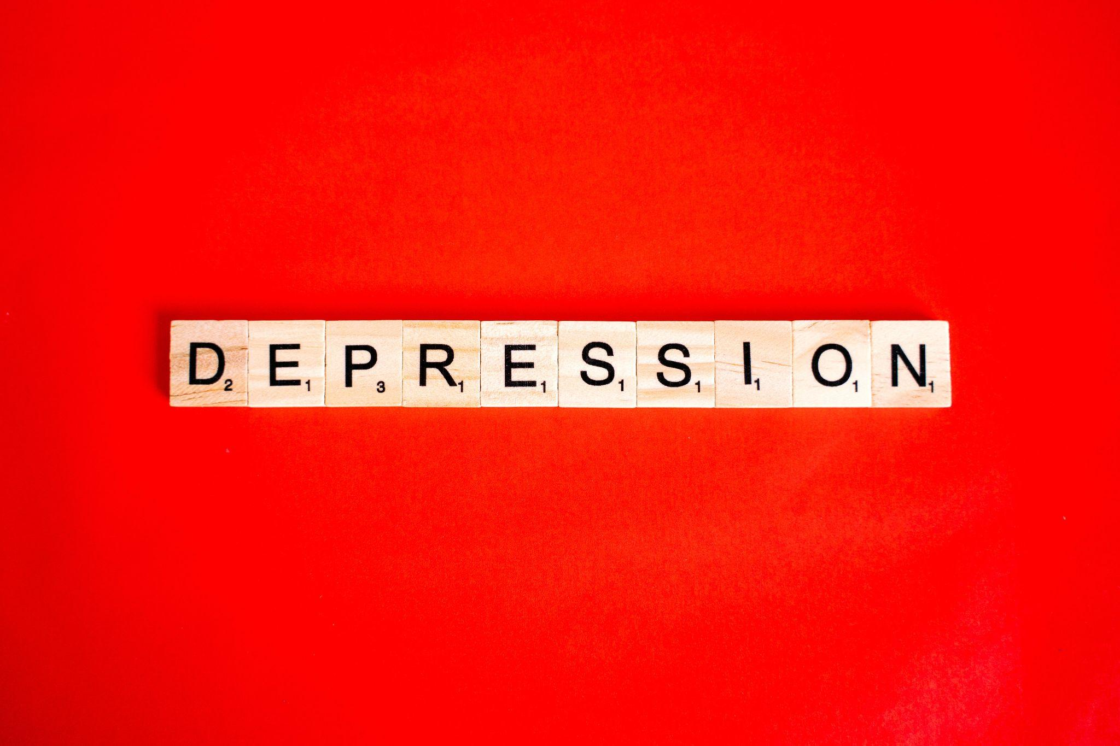

Image Link:https://www.pexels.com/photo/text-6136083/

Introduction

Erectile dysfunction happens when a man loses his ability to erect or maintain an erection. Erectile dysfunction affects all men of all ages. Research still shows that one in four men having erectile dysfunction also have depression. We can attribute the condition to many factors including dangerous lifestyles, poor diet, eating habits, trauma, and even genetics. In most cases, erectile dysfunctions are highly linked to depression and other psychological problems.
Men having erectile dysfunction rarely seek medical help due to shame and low self-esteem. These negative thought patterns continue to haunt men, leading to mental health and psychological illnesses. This blog aims to explain the relationship between erectile dysfunction and depression in men. It will also outline how the two conditions intermingle, affecting the general quality of life. To help you have an idea, let's begin with the basics.

What is depression?

Depression is a group of conditions that are characterized by low mood and frequent loss of interest in daily activities. According to the World Health Organisation, depression affects up to 5% of the global population. It is also a leading cause of disability and a major contribution to the overall global burden of diseases.
According to experts, having persistent or recurring irritability for over two weeks shows major depressive disorder (MDD). According to The American Psychiatric Association, depression is caused by four primary factors which include:

Genetics. Some of the defective genes that trigger depression run in families. People can be born with these genes and still act normal until these defective genes find a trigger and hence manifest as depression.

Environment. Scientists believe that the surroundings we live in affect the human state of well-being. For example, being exposed to harmful chemicals, toxic metals and harmful fumes can cause depression. Also, exposure to poverty, violence, and abandonment falls under this category.

Biochemistry. This involves brain chemistry and chemicals that regulate certain aspects of our bodies. A good example is dopamine imbalance within the brain.

Personality. Sometimes, diseases are caused by what people believe in. For example, pessimists (people who see life negatively) are most likely to have depression.

Relationship Between Erectile Dysfunction and Depression.

Research from a 2018 systematic review and meta-analysis showed a link between these two conditions. With the two conditions, most people think that erectile dysfunction causes depression. Yes, it is true but also depression causes erectile dysfunction as well. This happens because these factors are interrelated. To help you understand, it's important to remember that sexual urges begin in the brain.
This means that by the time an individual is having the actual sex, the idea is already present in the brain. For someone to have the best sexual intercourse, his/her sex life and mental health must be in alignment. Any imbalance between these two factors exposes someone to either negative thought patterns or erectile dysfunction.
Sometimes most men don’t even realize that their mental status is not okay, and it's affecting their sexual well-being. This happens because of a complex relationship that exists between sex hormones, the reproductive system, and mental health. Also, outstanding performance in bed for both men and women relies on a combination of two important factors, both physical and psychological.

Physical Factors

Physical factors could be medical conditions affecting the mental health status or the reproductive organs. They may include physical inactivity, being overweight, cardiovascular diseases, etc. They could also be trauma because of accidents or chronic illnesses. For example, diabetes is a major hormonal disorder that affects the body’s ability to regulate glucose (sugar) levels in the body.
When not treated well, the excess glucose remains in the blood, triggering several problems. This sugar damages small blood vessels and nerves. Damage to the nerves that control sexual stimulation and response can affect a man's ability to achieve an erection sufficient to have sexual intercourse. Reduced blood flow from damaged blood vessels can also contribute to erectile dysfunction.
Again, injury to the penis, spinal cord, prostate, bladder, or pelvis can affect a man’s penis and its surrounding muscles, causing erectile dysfunction. Because the functioning penis is such an integral part of most men, its failure to function can cause depression. This is because most men find it embarrassing to discuss their sexual dysfunctions and therefore don’t seek help.
Atomik Research's survey of 2,000 men indicated that 27 percent of men believe it is better to break up with their partner, rather than discuss their inability to have an erection with their doctors. Twenty-four percent of men said they felt unable to talk to their partner about erectile dysfunction. 22% of these men admitted that erectile dysfunction had led to a breakup.
33% of them aged between 18-60 agreed that they had told no one about their erectile dysfunction, which pushed them to depression. Forty-three percent of those affected by impotence said they could not even discuss the issue with friends and doctors. On the other hand, 23% will find it uncomfortable to talk to their GP.

Physiological Factors

Erectile dysfunction and depression occur when men's physiological systems are not in order. For instance, low testosterone levels can affect the body’s ability to supply blood to the penis, causing erectile dysfunction. Ideally, testosterone fuels a man's sex drive and performance. Therefore, low testosterone levels reduce a man’s ability to have satisfying sex because the sex drive is low.
Lack of sex drive and erectile dysfunction are the two most common sexual problems, which all lead to mental problems including depression. Again, aging also affects a man’s ability to have an erection or even maintain one. Aging can also cause impaired mental status which makes it difficult to have an erection. But how? As you age, various body systems also start shutting down.
This means that some of these systems may not work efficiently as they were functioning while young. Therefore, as men age, some of the blood vessels supplying the blood to the penis may not function, causing erectile dysfunction. Approaching age and frustrations of life may alter a man’s mental status, making it difficult to function sexually.

Further relationships between erectile dysfunction and depression can be studied by analyzing stress levels. Stress can be beneficial or detrimental. Sexual well-being again is linked to how well an individual’s stress management skills are.
Scientifically, different stress triggers different consequences in the body. One good example of the effects of bad stress is adrenal reactions. When a man is stressed, he goes through emotional turmoil. Cortisol is produced as a result of this stress. Cortisol is a hormone produced by the body when under stress and causes a wider range of effects. For sex to happen, blood vessels have to dilate (relax), avail blood to the penis, and make it stand erect.
The bad thing about cortisol is that it constricts (narrows) these blood vessels. This constriction avails little or no blood at all to the penis, hence hindering erection. Also, when these cortisol levels are too high in the body, they affect the production of testosterone. In other words, the higher the levels of cortisol, the lower the testosterone hormone. Being a hormone that regulates sexual stamina, low testosterone levels cause erectile dysfunction and depression, respectively.
The inverse is true. Men can achieve good stress through having sex for example. During active sexual intercourse, a lot of testosterone is produced, which blocks the production of cortisol. The by-product of this good stress then becomes great sexual performance and improved mental clarity.

The Bottom Line
Depression and erectile dysfunction are two interconnected conditions. They exist together in most cases because their causes or triggers are intertwined. Thanks to the technology that has enabled the complicated relationship between the two to be established. Currently, scientists still believe that having one of the two conditions (erectile dysfunction or depression) will eventually lead to the other.
The good news is that when discovered on time, both erectile dysfunction and depression are 100% treatable. While treating either of the conditions, it's important to consider other contributing factors as well. These may include cessation of cigarette smoking and alcohol drinking. Eating a balanced diet and engaging in regular exercises with medical treatment can help restore men’s sexual function, lift their self-esteem and improve their quality of life.
Would you like to know more about erectile dysfunction and depression relationships? If yes, kindly click these links:

https://primemensmedical.com/blog/depression-and-sex-can-depression-cause-erectile-dysfunction/

https://psychcentral.com/depression/depression-and-erectile-dysfunction#whats-the-link

https://www.urologymedicalgroup.com/blog/the-link-between-depression-and-erectile-dysfunction#:~:text=In%20fact%2C%20men%20with%20clinical,frustrate%20men%20and%20their%20partners.

https://www.atomikresearch.co.uk/50-of-male-brits-in-their-30s-suffer-erectile-problems/#:~:text=In%20fact%20a%20staggering%2027,actually%20led%20to%20a%20breakup.

